Chapter 15, Solution 40.

Let 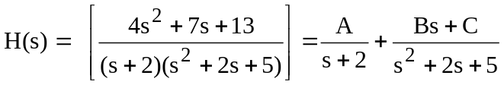

Equating coefficients gives:
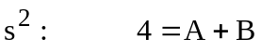

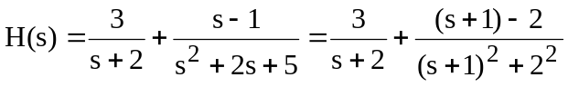
Hence,

where

Thus,

